Date: 10th September 2014
From
Madan H R
Ph.D Scholar
Department of Electronics,
Tumkur University, Tumkur – 572 013
(CMRTU Research Centre, RVCE Campus, Bangalore – 560 059)

Through,
Dr. S Ravishankar
Guide, CMRTU Research Centre, RVCE Campus, Bangalore – 560 059

To,
The Registrar
Tumkur University, Tumkur – 572 103

Respected Sir,
Subject: Resubmission of Research proposal for Ph.D registration in Electronics
Sir, with reference to the University letter dated 14th August 2014 ref: TU: AC: Ph.D/ECMHR/48/:2014-15, I am herewith re-submitting my research proposal titled “Design and Development of MODEM for Broadband Underwater Communication” after incorporating the methodology, for Ph.D registration in Electronics.
Thanking you with regards,
Yours sincerely,

(Madan H R)

RESEARCH PROPOSAL FOR Ph.D (ELECTRONICS)
TUMKUR UNIVERSITY, TUMKUR

Title: Design and Development of MODEM for broadband underwater communication

Madan H R
Ph.D Scholar
Department of Electronics,
Tumkur University, Tumkur – 572 013
(CMRTU Research Centre, RVCE Campus, Bangalore – 560 059)
email: madan.shaanbhog@gmail.com

Under the guidance of
Dr. S Ravishankar
Professor
CMRTU
R V C E Campus,
Bangalore – 560 059

Re-submission: 10th September 2014

Introduction and Motivation

While wireless communication technology today has become part of our daily life, the idea of wireless undersea communications may still seem far-fetched. However, research has been active for over a decade on designing the methods for wireless information transmission underwater. Human knowledge and understanding of the world’s oceans, which constitute the major part of our planet, rests on our ability to collect information from remote undersea locations.

The major discoveries of the past decades, such as the remains of Titanic, or the hydro-thermal vents at bottom of Deep Ocean, were made using cabled submersibles. Although such systems remain indispensable if high-speed communication link is to exists between the remote end and the surface, it is natural to wonder what one could accomplish without the burden (and cost) of heavy cables.

It’s is extremely difficult to achieve a high data rate communication link underwater due to various constraints such as poor propagation of electromagnetic signals underwater, high attenuation of acoustic signals , lack of accurate mathematical models of the underwater acoustic channel etc. Also, some of the wired underwater communication links would be prone to attacks by aquatic animals. Also, these wired links have problems related to dispersion and low data rate due to extreme pressure underwater.

Hence the motivation, and interest in wireless underwater communications. Together with sensor technology and vehicular technology, wireless communications will enable new applications ranging from environmental monitoring to gathering of oceanographic data, marine archaeology, and search and rescue missions, emergency Communications from a ship - Wired Media, mobile communication from a submarine, AUV with other stations that include ships, land based stations and other submarines – wireless acoustic media and many more.
The primary research goal of this project is to investigate various algorithms for underwater communication systems and hence enhance the performance.
Since, low data rate is the major bottleneck in successfully implementing an underwater communication system. The project aims to address the data rate issue by investigating numerous novel algorithms customized for underwater systems. This would be done by studying and optimizing the modulation schemes and the communication parameters for an underwater channel. The underwater channel model would be adopted from published literature and used for simulations. Then for this channel various studies would be performed to explore for better performance.

Communication channel

The signals that are used to carry digital information through an underwater channel are not radio signals, as electro-magnetic waves propagate only over extremely short distances. Instead, acoustic waves are used, which can propagate over long distances. However, an underwater acoustic channel presents a communication system designer with many difficulties.

The three distinguishing characteristics of this channel are frequency-dependent propagation loss, severe multipath, and low speed of sound propagation. None of these characteristics are nearly as pronounced in land-based radio channels, the fact that makes underwater wireless communication extremely difficult, and necessitates dedicated system design. Also, the acoustic transmitters are of low frequency hence bandwidth hungry video signals cannot be transmitted successfully

Wave propagation

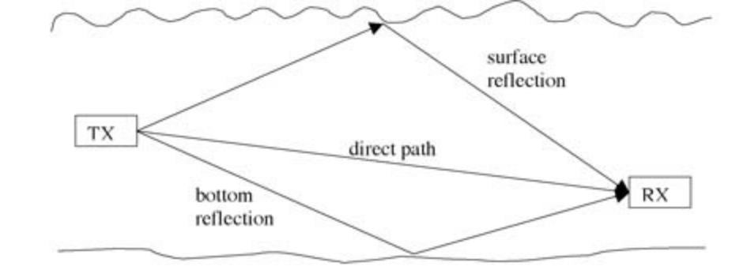
Fig. 1: Shallow water multipath propagation: in addition to the direct path, the signal propagates via reflections from the surface and bottom.

Path loss occurs in an acoustic channel over a distance and this loss severely limits the available bandwidth. Within this limited bandwidth, the signal is subject to multipath propagation, which is particularly pronounced on horizontal channels. In shallow water, multipath occurs due to signal reflection from the surface and bottom, as illustrated in Figure 1. In deep water, it occurs due to ray bending, i.e. the tendency of acoustic waves to travel along the axis of lowest sound speed. The channel response varies in time, and also changes if the receiver moves. Regardless of its origin, multipath propagation creates signal echoes, resulting in inter symbol interference in a digital communication system. While in a cellular radio system multipath spans a few symbol intervals, in an underwater acoustic channel it can spans few tens, or even hundreds of symbol intervals! To avoid the inter symbol interference, a guard time, of length at least equal to the multipath spread, must be inserted between successively transmitted symbols. However, this will reduce the overall symbol rate, which is already limited by the system bandwidth. To maximize the symbol rate, a receiver must be designed to counteract very long inter symbol interference.

The speed of signals underwater varies with depth and also depends on the environment. Its nominal value is only 1500 m/s, and this fact has a twofold implication on the communication system design. First, it implies long signal delay, which severely reduces the efficiency of any communication protocol that is based on receiver feedback, or hand-shaking between the transmitter and receiver. The resulting latency is similar to that of a space communication system, although there it is a consequence of long distances traveled. Secondly, low speed of sound results in severe Doppler distortion in a mobile acoustic system. Namely, if the relative velocity between the transmitter and receiver is ±v, then a signal of frequency fc will be observed at the receiver as having frequency fc (1±v/c). At the same time, a waveform of duration T will be observed at the receiver as having duration T(1±v/c). Hence, Doppler shifting and spreading occur. For the velocity v on the order of few m/s, the factor v/c, which determines the severity of the Doppler distortion, can be several orders of magnitude greater than the one observed in a land-mobile radio system! To avoid this distortion, a non-coherent modulation/detection must be employed. Coherent modulation/detection offers a far better utilization of bandwidth, but the receiver must be designed to deal with extreme Doppler distortion.

Summarizing the channel characteristics, one comes to the conclusion that an underwater acoustic link combines in itself the worst aspects of radio channels: poor quality of a land-mobile link, and high latency of a space link. In addition, current technology offers limited transducer bandwidth (typically a few kHz, or few tens of kHz in a wideband system), half-duplex operation, and limited power supply of battery-operated instruments.

Acoustic modem
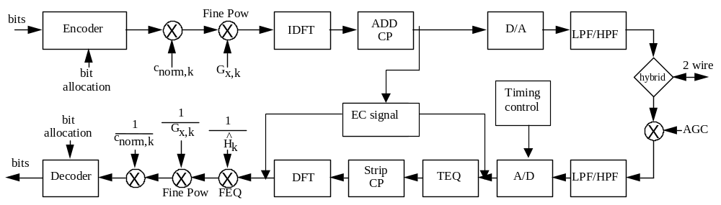

Fig 2: The block diagram of an acoustic Modem is as shown above.
The acoustic modem shown above employs OFDM technique, the details of which are as follows:

4.1. OFDM:

OFDM is a multicarrier modulation technique, which employs several carriers, within the allocated bandwidth, to convey the information from source to destination. Each carrier may employ one of the several available digital modulation techniques (BPSK, QPSK, QAM etc.,). OFDM is very effective for communication over channels with frequency selective fading, i.e., different frequency components of the signal experience different fading. OFDM is a special case of FDM (Frequency Division Multiplexing). In FDM, the given bandwidth is subdivided among a set of carriers. There is no relationship between the carrier frequencies in FDM.

4.2 OFDM Transmitter Design:

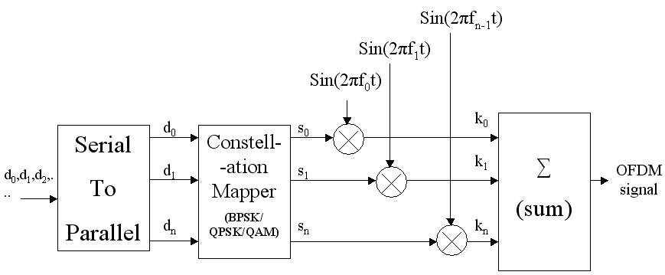
Fig. 3: OFDM Transmitter
Generally an OFDM signal can be represented by the equation:

Where s(t)= Symbols mapped to chosen constellation (BPSK, QPSK, QAM, etc..), f_{n}= Orthogonal Frequency.
Since the OFDM signal c(t) is in the discrete time domain, we use IFFT in the transmitter, Which is the process of converting frequency domain samples to time domain samples.

We use the IFFT/FFT equations for the conversion process and also to add and eliminate the individual sinusoidal multipliers required in the transmitter/receiver side.

Thus by using the IFFT and FFT blocks, we can eliminate the use of individual sinusoidal multipliers from the above shown block diagram.

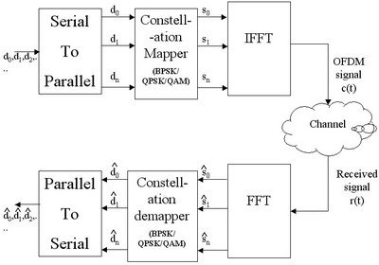

Fig. 4: OFDM Transceiver using IFFT/FFT blocks instead of individual sinusoidal multipliers
The FFT/IFFT length N defines the number of total sub-carriers present in the OFDM system.

In reality, not all the sub-carriers are utilized for data transmission. Some sub-carriers are reserved for pilot carriers (used for channel estimation/equalization and to combat magnitude and phase errors in the receiver) and some are left unused to act as guard band.

OFDM systems do not transmit any data on the sub-carriers that are near the two ends of the transmission band. These sub-carriers are collectively called guard band. The reservation of sub-carriers to guard bands helps to reduce the out of band radiation and thus eases the requirements on transmitter front-end filters. The sub-carriers in the guard band are also called Null sub-carriers or virtual sub-carriers.

Power equalization techniques are used to improve the signal quality and link performance over small scale times and distances by reducing Inter Symbol Interferences. 'Inter symbol interference' (ISI) caused by multipath in band limited (frequency selective) time dispersive channels distorts the transmitted signal, causing bit errors at the receiver. ISI has been recognized as the major obstacle to high speed data transmission over wireless channels.

We use OFDM combined with a time domain equalizer in this system. OFDM uses a cyclic prefix(CP) that is inserted at the beginning of each symbol to convert the linear convolution of data and channel into circular one. IF the CP is longer than the channel length, Inter symbol interference (ISI) is avoided. But the use of CP reduces the efficiency of the system. A TEQ is often used to reduce the channel length, enabling a shorter CP to be used.

The OFDM scheme uses symbols generated by a finite length FFT with size N. The orthogonality of consecutive OFDM symbols is maintained by appending a length 'v' cyclic prefix at the start of each symbol and so the length of the transmitted OFDM symbol is (N+v) samples. For each OFDM symbol to be independent and to avoid any Inter symbol Interference or inter carrier response, the length of channel impulse response (CIR) should be less than v+1 samples. The receiver takes only the last N samples for decoding at the receiver FFT, disregarding the CP.

One major disadvantage of OFDM system is the reduction in the transmission efficiency by a factor N/(n+v) caused by the CP. One way of increasing the efficiency is to increase the FFT size N, But this increases the complexity of the system and reduces the inter carrier spacing of sub-channels which subsequently makes the system more susceptible to frequency offset and oscillator phase noise

The alternative method is to use a Time Domain Equalizer (TEQ) preceding the FFT demodulator at the receiver in order to constrain the length of Effective Channel Impulse Response (EIR) to be shorter than the selected CP duration. This permits the use of a much shorter CP than could otherwise be employed and raises the transmission efficiency.

Objectives of the research work
- Investigate novel schemes for underwater communication system for performance enhancement
- Implement a novel design of a simple transmitter for a underwater communication

Methodology of research work

5.1. Characterization of underwater channel with a well known mathematical model, to be borrowed from published literature.
5.2. To survey the various novel communication schemes in Digital Communication such as wireless, to study MSE and BER performance: MIMO, OFDM, hybrid solutions would be explored from various journals dedicated to digital communication, the motive behind this is that the underwater acoustic communication channel would be fundamentally a digital communication system, novel ideas in a conventional digital system might be helpful for performance enhancement of underwater communication. Mathematical models for the same would be built using academic softwares. Also, the results published in the literature and simulated results would be compared. The primary difference between a conventional wireless channel and a underwater channel is the impulse response of the channel is quite different in both the cases.
5.3. Attempt to implement the same schemes and variations of it for an underwater communication channel in the theoretical domain. First, the mathematical model for underwater channel would be adopted from published literature, assuming realistic parameters. Later, the novel schemes simulated and tested (ideas from typical wireless systems) would be tested for a underwater channel.
5.4. Optimize the schemes for better performance. Once, the various schemes for a underwater channel is performed. Tweaking of the scheme or optimization process would be performed to extract suitable results. In other words, the communication system’s scheme would be customized for a underwater scenario.
5.5. Finalize the schemes for enhanced performance for an underwater channel and then implement the same for design of the transmitter on a FPGA or DSP chip, which is a sub-functional unit of a proposed transmitter.
5.6. Compare and contrast the new model with previously established schemes
5.7. Communication of the results to referred journals and conferences

References

Haykin S., Communication System, 4th edition, John Wiley and Sons, 2001 Bertsekas D. and GaIlager R., Data Networks, 2“ Edition, Prentice-Wall Inc., I992
Vijay K Garg, Wireless Communications and networking, Elsievier, 2007, ISBN: 978-0-12-373580-5
Haykin S., Adaptive Filler Theory, Fourth Edition, Prentice Hall, 2002
Liu, L.; Zhou, S.; Cui, J.-H. Prospects and problems of wireless communications for underwater sensor networks. Wirel. Commun. Mob. Comput.-Spec. Issue Underw. Sens. Netw. 2008, 8, 977–994
X. Cheng, R. Griffin, F. Qu, and L. Yang, ”Multi-band OFDM for underwater acoustic communications,” in Proc. of Acoustic, Hong Kong, China, May 2012, pp. 1052–1057
M. Wen, X. Cheng, X. Cheng, L. Yang, D. Duan, and B. Jiao, ”Effective intercarrier interference reduction techniques for OFDM underwater acoustic communications”, in proceedings of Asilomar Conf. Signals Sym. Put. Pasific Grove, CA, USA, Nov. 2013, pp. 93-97
K. Tu, T. Duman, M. Stojanovic, et al., “Multiple-Resampling Receiver Design for OFDM over Doppler-Distorted Underwater Acoustic Channels”, IEEE Journal of Oceanic Engineering, 2013. 38(2): pp. 333-346
S. Xu, G. Wan, “Joint Optimization of PAPR and ICI for the OFDM System Basedon the Fractional Fourier Transform”, Proceedings of the 9th International Symposium on Linear Drives for Industry Applications, Volume 1, 2014, pp 251-258
H. C. Song. “Time reversal communication in a time-varying sparse channel”, The Journal of the Acoustical Society of America, 2011, 130(4):EL161-166
Ethem M. Sozer, “Simulation and Rapid Prototyping Environment for Underwater Acoustic Communications: Reconfigurable Modem”, Oceans – Europe-IEEE, pp. 80-85, 2005
D. Brady and J. C. Preisig, “Underwater acoustic communications”, Wireless Communications: Signal Processing Perspectives (H.V.Poor and G. W. Wornell, eds.), ch. 8, pp. 330–379, Prentice-Hall, 1998.
M. Stojanovic, J. A. Catipovic, and J. G. Proakis, “Phase-coherent digital communications for underwater acoustic channels,” IEEE J. Oceanic Eng., vol. 19, pp. 100–111, Jan. 1994.
J. C. Preisig and G. Deane, “Surface wave focusing and acoustic communications in the surf zone,” J. Acoust. Soc. Am., vol. 116, pp. 2067–2080, Oct. 2004.
B. Li, S. Zhou, M. Stojanovic, and L. Freitag, “Pilot-tone based ZPOFDM demodulation for an underwater acoustic channel,” in Proc. IEEE OCEANS, Sept. 2006, pp. 305-309
M. Stojanovic, “Low complexity OFDM detector for underwater acoustic channels,” in Proc. IEEE OCEANS, Sept. 2006.
A. K. Morozov and J. C. Preisig, “Underwater acoustic communications with multi-carrier modulation,” in Proc. IEEE OCEANS, Sept. 2006.
Y. Li and L. J. Cimini, Jr., “Bounds on the interchannel interference of OFDM in time-varying impairments,” IEEE Trans. Commun.,vol.49, pp. 401–404, Mar. 2001.
R. Raheli, A. Polydoros, and C. K. Tzou, “Per-survivor processing: A general approach to MLSE in uncertain environments,” IEEE Trans. Commun., vol. 43, pp. 354–364, Feb./Mar./Apr. 1995.
B. Li, S. Zhou, M. Stojanovic, L. Freitag, and P. Willett, “Non-uniform Doppler compensation for zero-padded OFDM over fast-varying underwater acoustic channel,” in Proc. IEEE OCEANS, June 2007.
W. Kozek and A. F. Molisch, “Nonorthogonal pulseshapes for multicarrier communications in doubly dispersive channels,” IEEE J. Select.Areas Commun., vol. 16, pp. 1579–1589, Oct. 1998.
T. Strohmer and S. Beaver, “Optimal OFDM design for time-frequency dispersive channels,” IEEE Trans. Commun., vol. 51, pp. 1111–1122, July 2003.
K. Liu, T. Kadous, and A. M. Sayeed, “Orthogonal time-frequency signaling over doubly dispersive channels,” IEEE Trans. Inform. Theory, vol. 50, pp. 2583–2603, Nov. 2004.
S.-J. Hwang and P. Schniter, “Fast noncoherent decoding of block transmissions over doubly dispersive channels,” in Proc. Asilomar Conf. Signals, Systems and Computers, Nov. 2007.
M. K. Tsatsanis and G. B. Giannakis, “Modeling and equalization of rapidly fading channels,” Int. J. Adaptive Control & Signal Processing, vol. 10, pp. 159–176, Mar. 1996.
T. H. Eggen, A. B. Baggeroer, and J. C. Preisig, “Communication over Doppler spread channels—Part I: Channel and receiver presentation,” IEEE J. Oceanic Eng., vol. 25, pp. 62–71, Jan. 2000.
W. Li and J. C. Preisig, “Estimation and equalization of rapidly varying sparse acoustic communication channels,” in Proc. IEEE OCEANS, Sept. 2006.
S.-J. Hwang and P. Schniter, “Efﬁcient communication over highly spread underwater acoustic channels,” in Proc. ACM Int. Workshop Underwater Networks (WUWNet), Sept. 2007.
W. C. Jakes, Microwave Mobile Communications. Wiley, 1974. [reprinted by IEEE Press].

